Instructions to Authors for the Preparation of Manuscripts for Mineral Processing 2024 – 7TH International Conference, ULAANBAATAR MONGOLIA
*Zorigtkhuu Davaanyam¹, **Ganbold Malkhuuz²

¹Erdenet Institute of Technology
Sh.Otgonbileg St., Bayan-Undur Soum, Orkhon province, Mongolia
(*Corresponding author: zorigtkhuu@eit.edu.mn)

²Oyu Tolgoi LLC
Monnis Tower, Ulaanbaatar, Mongolia
(**Original author for Mineral Processing 2024 Conference: ganboldm@ot.mn)

Abstract
This document sets out the requirements for preparing and submitting manuscripts for publication in the Mineral Process 2024 International Conference. In order for the Proceedings to have a consistent and professional appearance, it is essential that all manuscripts conform to these instructions. This “author friendly” document itself serves as an template of a correctly prepared manuscript.

Keywords
Instructions, authors, Mineral Processing 2024 International Conference, deadlines



Introduction
Manuscript should not exceed approximately 15 pages in length, including text, figures, tables, and references.
Authors are responsible for ensuring the accuracy of all information contained in their manuscripts (e.g., proper names of organizations, data and findings, references, etc.).
Manuscripts must be prepared in proper English.
These instructions will enable you to prepare your manuscript in an electronic format, ready for submission and general review. It is therefore essential that these instructions be carefully followed.

Preparation of the Manuscript
Prepare your manuscript using Microsoft Office Word as your word processing software. To ensure that your manuscript has an identical appearance when viewed on almost any computer, use the Unicode (UTF-8) international character set.

PAGE SIZE AND LAYOUT
Your manuscript must be prepared for European A4-size (210 x 297 mm) paper. Use the margin settings specified in Table 1. These Instructions serve as a template for your paper which may be useful in getting started.
Table 1 – Manuscript margins
Margin | A4 (210 x 297 mm)
Top | 2.5 cm
Bottom | 2.5 cm
Left | 3.0 cm
Right | 2.0 cm

Type Style and Spacing
All headings and text must be typed in Times New Roman font. Use 12 point type size for body and table text throughout your manuscript, including captions. Use single line spacing throughout.

Title Page
The title page of your manuscript is illustrated by the first page of these instructions. The title page must not exceed one (1) page in length. It contains:
The title of the paper in bold 14 point Times New Roman, flush left with the first letter of each major word of the name capitalized. Text colour and full-length underline colour is Red: 0, Green: 57 and Blue: 106 (#00396a).
The author’s name in regular black, 12 point Times New Roman, with the first letter of each part of the name capitalized. Indicate the primary author with an asterisk (*) if there is more than one author.
The author’s affiliation and address, immediately below the name, left-justified and single-spaced, in 12 point Times New Roman.
If applicable, the names of other (co)authors, having different affiliations and addresses, in the same format used for the first author, with each affiliation entry separated by a blank line (12 points). Identify each author’s affiliation with superscript digits after an author’s name that corresponds to superscript digits before each affiliation.
The major heading Abstract, flush left with the first letter of each part of the name capitalized, in bold Times New Roman.
The body of the abstract, not to exceed 200 words in length, in regular Times New Roman, flush left, separated from the heading Abstract by one (1) blank.
The major heading Keywords, with the first letter capitalized, in bold Times New Roman, separated from the last line of the abstract by four (4) blank lines.
The list of keywords, not to exceed ten (10) words, in regular Times New Roman, left justified, separated by commas, and separated from the heading Keywords by one (1) blank line. Please add those keywords that you would use if you were searching for your paper.

Body of Paper
The body of the paper begins at the top of the second page of the manuscript. Any space remaining on the first page (i.e., the title page) is left blank.
The main text of the paper begins following the title, the abstract, and the keywords. Separate the sections of the main text in accordance with the Headings guidelines below.

Headings
Use the predefined heading styles. The manuscript will typically have three levels of headings: major (using style Heading 1), second-level (using style Heading 2), and third-level (using style Heading 3). All headings are in Times New Roman type.
Major headings, such as Abstract, Introduction, Experimental, Engineering Design, Operating Results, Cost Analysis, Safety, Discussion, Conclusions, Acknowledgements, References, are flush left and 13-point Times New Roman font, bold-faced, full-length underline, and the initial letter of each major word capitalized. Color of major headings is Red: 0, Green: 57 and Blue: 106 (#00396a). The main text of the paper begins with a major heading (for example, Introduction). Subsequent major headings are separated from the text above and below them by one (1) blank line (this separation line is automatically generated if the Heading 1 style is used); they do not begin a new page unless it is strictly required.
Second-level headings are 12 point Times New Roman font, bold-faced, have the all letters capitalized, and are positioned at the left margin. Third-level headings are 12 point Times New Roman font, bold faced, have the initial letter of each major word capitalized, and are positioned at the left margin. Both are separated from the text above and below by one (1) blank line.

Text
Text paragraphs are single-spaced 10 point Times New Roman with no indentation and are fully justified. Paragraphs are separated with a blank line (or use the Body style configured in the template with 6 point top spacing and 8 point bottom spacing).
The template document includes two styles pre-defined for your use: Body includes the automatic spacing between paragraphs of text and Normal does not include spacing between paragraphs. Use the Body style for most text and the Normal style in tables and other situations where the spacing between paragraphs is not used.

Writing Style and Spelling
Use clear and concise writing throughout the paper, as well as proper English spelling.

Footnotes
Do not use footnotes. Incorporate all required information in the body of the paper.

Page Headers and Footers
If using the provided template Word file, do not change the pre-defined blank header or the pre-defined footer. If not using the template Word file, leave the document header and footer blank and they will be added by the Technical Editors.

Bullets and Numbers
Bullets should be flush left with a hanging indent of 0.63 cm.
Numbers should be in the format 1. 2. 3., fully justified with a hanging indent of 0.63.

Equations and Symbols
Simple mathematical expressions and sub- and super-scripted characters, such as SO₄²⁻, are inserted in the text. More complex equations are inserted using the Microsoft Office equation editor. Do not embed equations as an image.
Equations are placed on separate lines, centred and numbered consecutively in parentheses at the right-hand margin. A blank line precedes and follows each equation. For reactions, preferably use the Times New Roman Unicode (normal text) arrow (see Equation 1a), but an equal sign may be substituted (see Equation 1b). Use a dash rather than a hyphen for the minus sign.
Use the Equation style in the template to automatically set the equation positions: put a tab in front of the equation and a second tab between the equation and its number.
$W=W_{i}\left(\frac{10}{\sqrt{P_{80}}}-\frac{10}{\sqrt{F_{80}}}\right)$ (1)
The nomenclature and units for symbols must be defined in the text or, where the number of symbols is large, include a special section, NOMENCLATURE, at the end of the paper. Please organize the definitions alphabetically starting with Roman symbols, then proceeding to Greek symbols.

Figures
All figures should be high resolution (300 dpi) when published at 100% (e.g., images at 72 dpi are, in actuality, 25% of the required resolution). Figures including graphs (such as Figure 1), line drawings, photographs and other illustrations are preferably in colour. Any greyscale figures require sharp contrast. For all figures, lines and lettering must be large enough (minimum 0.35 point thickness) to remain clearly legible when printed at 100%. For maps, microstructures and similar figures, be sure to place a scale marker on the picture or photograph. Do not use frames around figures. Do not use shaded backgrounds as they do not reproduce well.
Figures, especially photographs and SEM micrographs, can significantly increase the size of the electronic file. Excessively large files tend to complicate and slow down the editing process. Therefore, you must make every effort to reduce the size of the electronic files of your photomicrographs and other graphics. To minimize your file size, add the figures (photos, photomicrographs) using the "Insert-Picture" function. For Excel charts, use the "Copy-Paste, Special-Picture" sequence.
All figures should be centred on the page and must be consecutively numbered with Arabic numerals and inserted as close as possible to the corresponding text. In the text, refer to the figure by its number, not its relative position. A figure too wide to fit between the margins may be placed in landscape orientation (sideways format), on a page by itself, with the bottom of the figure to the right of the page. A caption consisting of the word “Figure,” the figure number, a dash and the figure title, in 10 point Times New Roman, must appear centred below each figure. A single blank line is used to separate a figure from its caption. Separate each figure and caption from the adjacent text with one (1) blank line. Do not use a period at the end of the figure caption.
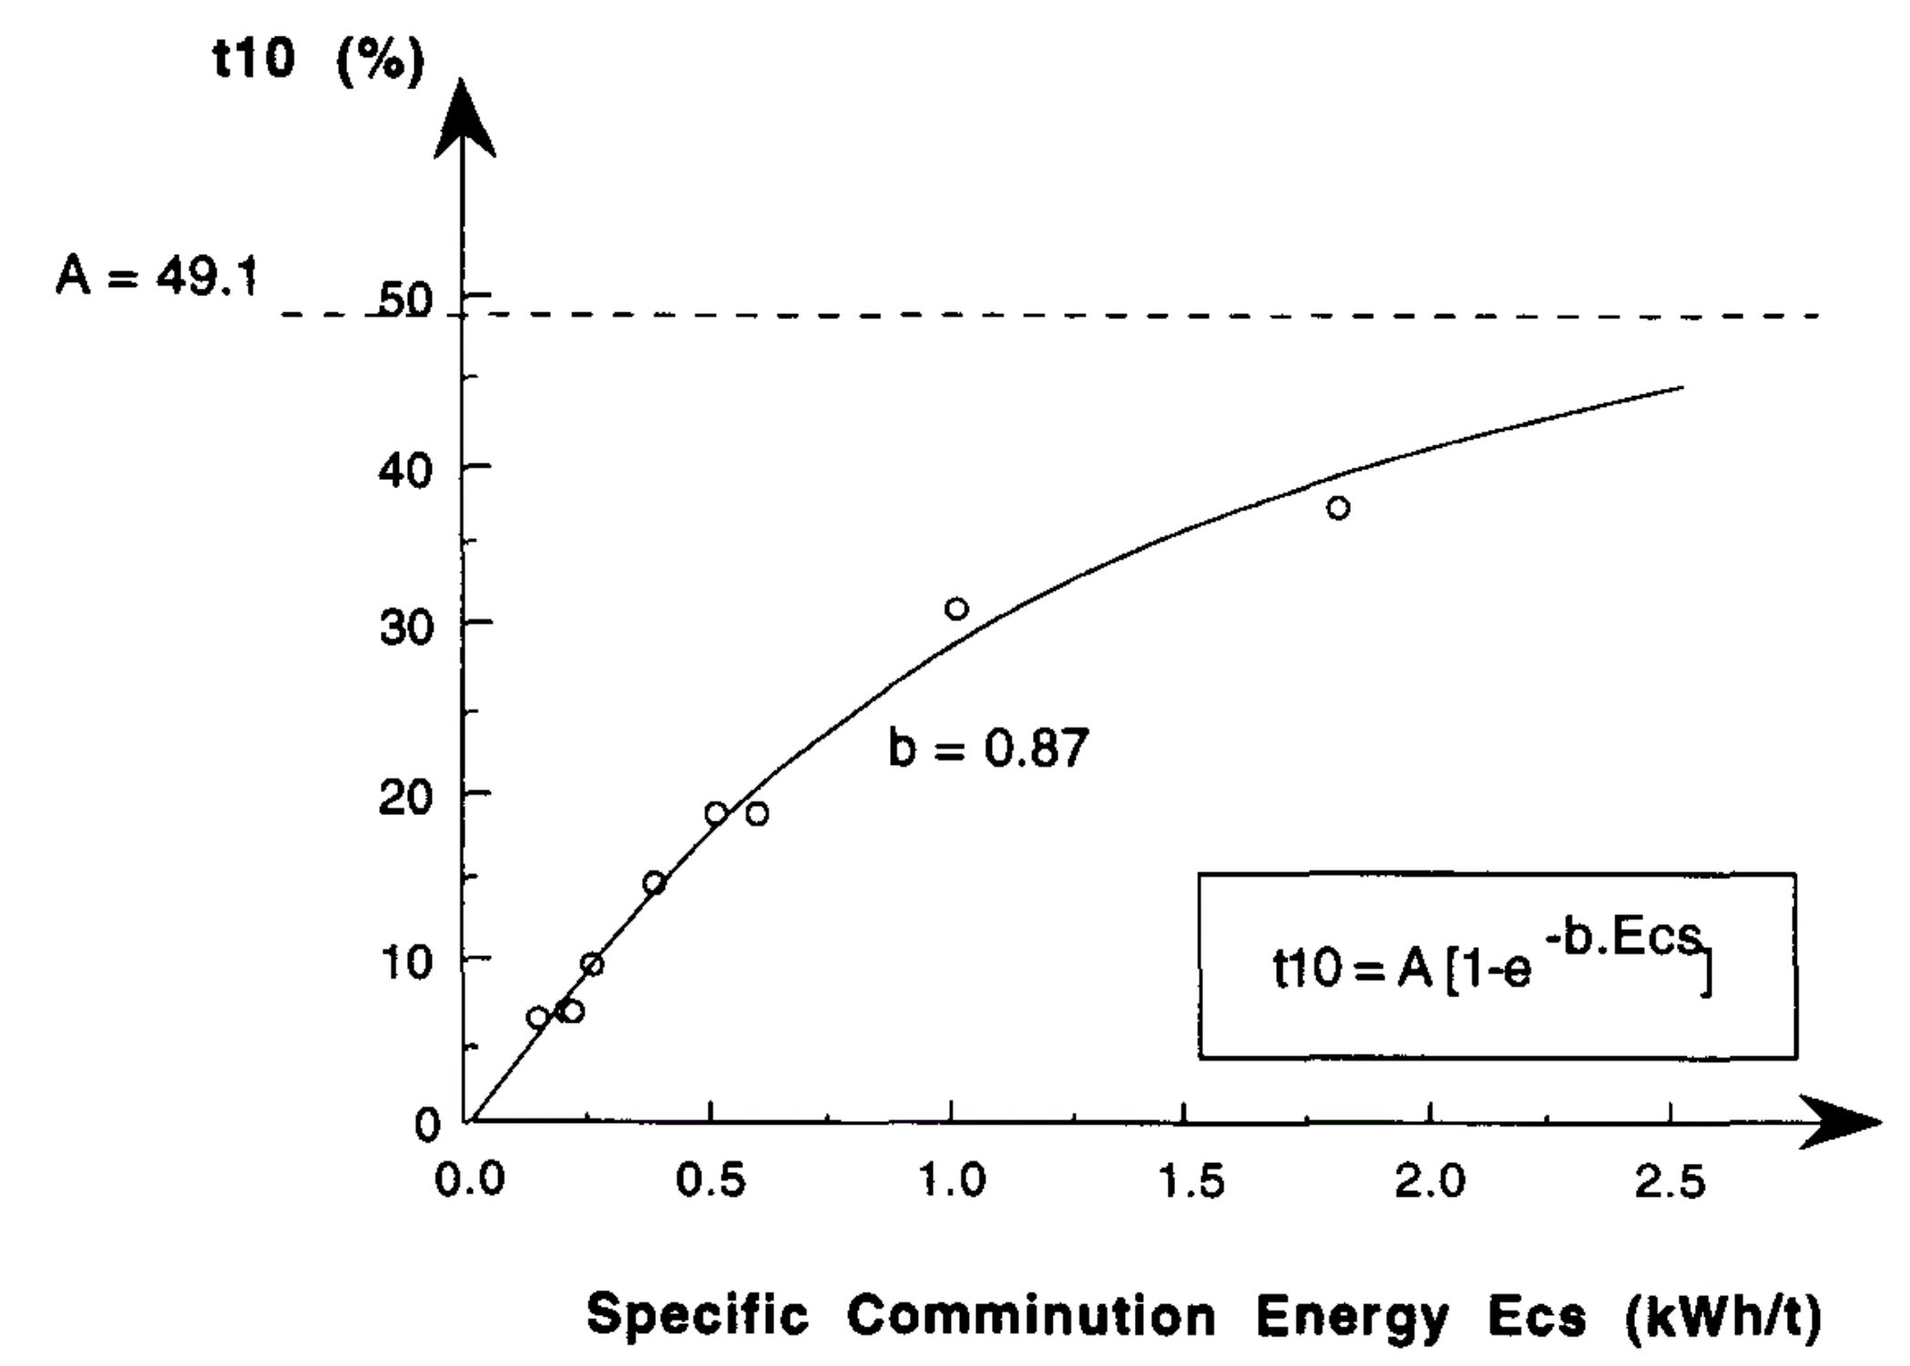
Figure 1 – An example of relationship between t10 and specific comminution energy

Tables
Tables should be centred on the page and inserted as close as possible to their first citation. In the text, refer to a table by its number, not its relative position. A large table, like a large figure, may be placed in landscape orientation (sideways format) on a page by itself. Number tables consecutively using Arabic numerals and centre the title above the table. The word “Table” is followed by the table number, an M-dash (–), and the rest of the title. There is no line space between the title and the table itself.
Table-wide lines (horizontal ½ point thickness) separate the title from the column headings, the column headings from the body of the table, and the table from the following text. Do not use vertical lines and avoid the use of horizontal lines between the various rows of data. Separate each table from the adjacent text with one (1) blank line.
Table 2 – Assay results
Element | Average Content  (wt %) | Range  (wt %)
Zn | 60.8 | 59.6 – 63.3
Fe | 5.82 | 3.54 – 6.95
Cd | 0.30 | 0.12 – 0.42
S | 3.31 | 33.6 – 33.5

References
APA referencing style (American Psychological Association, 2009) must be employed for all references, including both parenthetical references in the text and the reference list at the end of the paper. In the reference list, only those publications that have actually been cited in the text, figures, and tables should be included.

Instructions Summary
Word Processing Software | Microsoft (MS) Word DOCX file
Page Setup (Paper/Margins) | See Table 1, Section Page Size and Layout
Font: | Colour black, Times New Roman.  This font applies to complete manuscript and all headings
First page  (Manuscript Title): | Start from top margin  bold/title/case/flush left between page margins. Full-length underline.
Author Name(s): | Left page margin, list on single line (if possible) and use superscripts to identify affiliations. Leave (1) blank line between affiliation names and addresses.

Manuscript Headings
Major Heading | Times New Roman 13 point/bold/major words capitalized/justified left margin.  Leave (1) blank 10-point line above/below Major Heading if not using the provided Heading 1 style. Color #00396a. Full length underline.
SECOND LEVEL HEADING | Times New Roman 12 point/bold/all letters capitalized/justified left margin.  Leave (1) blank 10 point line above/below Second Level Heading if not using the provided Heading 2 style. Colour black.
Third Level Heading | Times New Roman 12 point/bold/major words capitalized/justified left margin.  Leave (1) blank line above/below Third Level Heading. Colour black.
Figure headings/captions | Times New Roman 11 point. Figure 1 – Centred below figure. First major word is capitalized. There is (1) blank line between figure caption and figure. There is (1) blank line above/below figure. No punctuation after figure caption
Table headings | Times New Roman 11 point. Table 1 – Centred above table. First major word capitalized. There is no line spacing after table heading. There is (1) blank line above/below table. No punctuation after table heading.
Equations | Centred with equation number in (parentheses) at the right margin, one (1) blank line above/below equation
References | APA style referencing (see Referencing Guide)

Types of Referenced Materials

Periodicals (e.g., journal, newsletter, magazine)
Use the following general form:
Author, A. A., & Author B. B. (year). Article title. Periodical Title, volume #, first page-last page. doi:xxxxxxxxxx
Italicize the periodical title and the volume number, but do not italicize the article title. Place a period after the article title and after the page numbers. Place commas after the periodical title and after the volume number. Use uppercase and lowercase letters for the periodical title, but not for the article title. The periodical title should be written in full; do not use abbreviations.
Polansky, K., Fairman, P. S., & Singh, B. (2010). Estimating oil reserves: An exploration of new approaches. Journal of Metallurgy, 32, 144-156. doi: 10.3423/726578923456
For periodicals that begin each issue on page 1, place the issue number in parentheses immediately following the volume number. Do not italicize the issue number.
Plansky, K., Fairman, P. S., & Singh, B. (2010). Estimating oil reserves: An exploration of new approaches. Journal of Metallurgy, 32(3), 144-156. doi: 10.3423/726578923456

Entire Books
Use the following general format:
Author, A. A., & Author, B. B. (year). Book title. Location: Publisher.
Italicize the book title and capitalize only the first letter of the first word. Place a period after the title and after the publisher and a colon after the location.
For books retrieved electronically, provide the DOI instead of the location and publisher.
Author, A. A., & Author, B. B. (year). Book title. doi:xxxxx
For books retrieved electronically without an assigned DOI, provide the URL instead of the location and publisher.
Author, A. A., & Author, B. B. (year). Book title. Retrieved from http://www.xxxxx
Place any additional information required for retrieval (e.g., edition, volume number) in parentheses, following the title. Refer to the list of common abbreviations.
Garibaldi, S. (2008). Optimizing production: New solutions to old problems (3rd. ed., Vol. 1). New York, NY: Active Publisher.
Place any non-routine information required for retrieval (e.g., brochure, special issue) in brackets, following either the title or the additional information in parentheses.
Johnson, L., & Harrington, S. A. (2007). Safety tips (2nd ed.) [Brochure]. Retrieved from http://www.xxxxxxxxx

Chapter in a Book
Follow the same format as the one used for entire books and include additional information about the chapter title, editor(s), and chapter page numbers. Use the following general format:
Author, A. A., & Author, B. B. (year). Chapter title. In A. Editor & B. Editor (Eds.), Book title (pp. xx-xx). Location: Publisher.
Place the chapter title after the year of publication using uppercase and lowercase letters. Do not italicize the chapter title. Place a period after the chapter title. After the chapter title, introduce the editor with the word In, then list the editors by initial(s) and surname. Place the abbreviation Ed. in parentheses (Eds. for multiple editors), followed by a comma and then the book title. In parentheses following the book title, write pp. and then the first and last page numbers of the chapter, separated by a hyphen (-).
Tilmann, C. (2010). Methodological concerns. In N. Thernhold, L. Ludwig, & B. B. Trolanski (Eds.), Jumpstarting the future (2nd ed., pp. 134-152). Melbourne, Australia: Feigned Publishing.

Technical and Research Reports
Follow the same format as the one used for entire books and include additional information about the type of work and assigned retrieval number (if one has been assigned) in parentheses following the report title. Use the following general format:
Author, A. A., & Author, B. B. (year). Report title (Type of Work No. xxxx). Location: Publisher.
Identify the type of work (research report, technical report, issue brief, etc.) in uppercase and lowercase letters. Do not italicize the type of work.
If the work has been assigned a retrieval number, write No. after the type of work, followed by the retrieval number.
Department of Media Affairs (2004). Survey of federal programs (Tech. Rep. No. 231-234-96). Ottawa, ON: Author.
As with other types of publications retrieved online, replace the location and publisher with Retrieved from and the DOI or URL. When the publisher is not the same as the author, identify the publisher in the retrieval statement.
Abergale Consulting (2007). The HR crisis: Building capacity (Issue Brief). Retrieved from Association of Geologists website: http://www.xxxx.org/yyyy.pdf

Published Meetings, Symposia, and Conference Presentations
For proceedings of meetings, symposia, and conference presentations that are published in a book, follow the same format as the one used for chapters in a book.
Côté, C. (2003). A practical guide to policy implementation. In K. A. Purdy & B. Stein (Eds.), Ninth International Conference on Occupational Diversity (pp. 432-445). Portland, OR: Linkset Press.
For regularly-published proceedings, follow the same format as the one used for periodicals.
Trakis, L., & Richardson, R. (2008). Cost-benefit versus cost-effectiveness. Proceedings of the Financial Enterprise Association, 37, 44-52.

Unpublished Papers and Poster Sessions
For unpublished papers and poster sessions presented at a conference, use the following general format:
Presenter, A. (year, month). Paper/poster title. Paper/poster session presented at the Name of Conference, Location.
For unpublished papers and poster sessions presented at a meeting, use the following general format:
Presenter, A., & Presenter, B. (year, month). Paper/poster title. Paper/poster session presented at the meeting of Name of Organization, Location.
When the work has not been published, include the month after the year, separated by a comma. Following the title of the paper or poster, identify the type of work (paper or poster session) and to whom it was presented (the name of the conference or of the organization holding the meeting). End this segment of the reference with a comma, then identify the location at which the conference or meeting took place.
Bloomfield, R. (2010, March). Striving for success. Poster session presented at the Fourth International Conference on Management Accountability, Paris, France.

Unpublished Symposia
For unpublished contributions to symposia conducted at conference, use the following general format:
Contributor, A., Contributor, B., & Contributor, C. (year, month). Contribution title. In A. A. Chairperson (Chair), Symposium title. Symposium conducted at the Name of Conference, Location.
For unpublished contributions to symposia conducted at meeting, use the following general format:
Contributor, A., Contributor, B., & Contributor, C. (year, month). Contribution title. In A. A. Chairperson (Chair), Symposium title. Symposium conducted at the meeting of Name of Organization, Location.
Follow the same format as the one used for unpublished papers and poster session, and include additional information about the chairperson. After the contribution title, introduce the chairperson with the word In, then identify the chairperson by initial(s) and surname. Place the word Chair in parentheses, followed by a comma and then the symposium title. Use italics for the symposium title, but not for the contribution title.
Hamilton, F., & Morisson, V. B. (2006, September). Multicultural perspectives. In J. Yaelle (Chair), Sustainability in remote locations. Symposium conducted at the meeting of the Association of Innovation, Yellowknife, NT.

Unpublished Manuscript Within a University
Use the following general format:
Author, A. (year). Manuscript title. Unpublished manuscript, Department Name, University Name, Location.
Following the manuscript title, write Unpublished manuscript (no italics) and then identify the name of the department, the name of the university, and the location of the university, all separated by commas.
Shelling, O. (2009). Assumption-checking in multivariate analysis. Unpublished manuscript, Department of Statistics, Pi University, Vancouver, BC.

Doctoral Dissertations and Masters’ Theses Available from a Database
Use the following general format:
Author, A. (year). Dissertation or thesis title (Doctoral dissertation or master’s thesis). Retrieved from Name of Database. (Accession or Order No. xxxx)
Immediately after the title, identify in parentheses whether the work is a doctoral dissertation or a master’s theses, followed by a period. Then identify the database from which the work can be retrieved, followed by a period. Provide the accession or order number, in parentheses, at the end of the reference.
Butler, T. E. (2003). Stock forecasting: Planning for uncertainty (Doctoral dissertation). Retrieved from International Dissertations Warehouse. (Order No. 236-43-236)

Unpublished Doctoral Dissertations and Masters’ Theses
Use the following general format:
Author, A. (year). Dissertation or thesis title (Unpublished doctoral dissertation or master’s thesis). Name of Institution, Location.
Immediately after the title, identify in parentheses whether the work is an unpublished doctoral dissertation or an unpublished master’s thesis, followed by a period. Then provide the name of the institution and the location, separated by commas.
Champagne, P. (2007). Sustainable development: Enhancing host-country capacity (Unpublished master’s thesis). Edwin University, Cardiff, Wales.

Software
Do not provide reference entries for standard software, such as Microsoft Office and Adobe Acrobat.
For other software, use the following general format:
Software Name (Version xx) [Computer software]. Location: Name of producer.
Do not italicize the software name. Immediately after the software name, place the version number in parentheses and then write Computer software in brackets, followed by a period. Identify the location and the name of the producer, separated by a colon.
ChanaMax(Version 2.1) [Computer software]. Waterloo, ON: Cantric Research.

Patents
Use the following general format:
Inventor, A. (year). U.S. Patent No. xxx,xxx,xxx. Washington, DC: U.S. Patent and Trademark Office.

Follow the same format as the one used for entire books, but replace the author’s name with the inventor’s name. The year represents the patent’s issue date.
Hardy, N. (2007). U.S. Patent No. 302,598. Washington, DC: U.S. Patent and Trademark Office.

In text, cite the patent number and issue date.

